**Autonomous Vehicle**

***Abstract:***

Over the last years the automotive industry has advanced signiﬁcantly towards a future without human drivers. Researchers are currently trying to overcome the technological, political and social challenges involved in making autonomous vehicles mainstream. These vehicles need to be safe, reliable and cost-efficient. Connecting them and creating coordination mechanisms could help achieving these goals.

This report explores autonomous (also called self-driving, driverless or robotic) vehicle benefits and costs, and implications for various planning issues. It investigates how quickly self-driving vehicles are likely to be developed and deployed based on experience with previous vehicle technologies, their benefits and costs, and how they are likely to affect travel demands and planning decisions such as optimal road, parking and public transit supply.

This analysis indicates that some benefits, such as more independent mobility for affluent non-drivers, may begin in the 2020s or 2030s, but most impacts, including reduced traffic and parking congestion (and therefore infrastructure savings), independent mobility for low-income people (and therefore reduced need for public transit), increased safety, energy conservation and pollution reductions, will only be significant when autonomous vehicles become common and affordable, probably in the 2040s to 2050s, and some benefits may require prohibiting human-driven vehicles on certain roadways, which could take even longer.

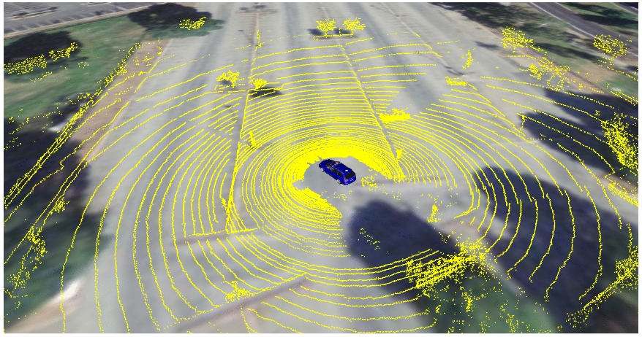

***Introduction***

Automobile manufacturers such as Ford, General Motors, Tesla, and other companies such as NVIDIA are investing billions of dollars in autonomous vehicle driving research. According to Intel, by 2050, this fast-growing industry will be worth $ 7 trillion [25]. Governments of countries in Europe and of the USA are creating regulations for self-driving cars, as a result of the latest advances of the industry. The benifits of fully autonomous vehicles can go way beyond removing the need of a human driver. Transportation services such as Uber will start using self driving cars instead of human drivers, and might become a cheaper and better Alternative for end consumers than owning a car. This will represent a shift on the way cities are planned, as fewer parking places will be needed, and most importantly, in a smart city with most of its vehicles being connected and autonomous, traffic optimization will be able to be heavily applied by coordinating movement. This will result in a major decrease on travel time, and it will also save lives as emergency services will be able to reach their destinations faster.

In contrast, there are many problems that need to be addressed regarding autonomous vehicles. Tesla’s car autopilot ﬁrst fatal crash in 2016 [9], for example, brought up discussions about reliability, safety and legal liability regarding autonomous vehicles among researchers. Other important topics, such as security and transparency will need to be heavily discussed as these vehicles become mainstream.

***Autonomous vehicle movement coordination(benefits & usage scenarios):***

In this section, we will present possible scenarios of autonomous vehicle movement coordination, and what beneﬁts they would bring regarding trafﬁc and security.

**Scenario 1: emergency lane changes**

Whether on highways or two-lane roads it may happen that an obstacle will suddenly require a lane change, for example, when an animal crosses the road, or when a landslide occurs. This sudden lane change may represent a dangerous situation, as it is possible that the vehicles on the other lane are approaching from behind in a much higher speed.

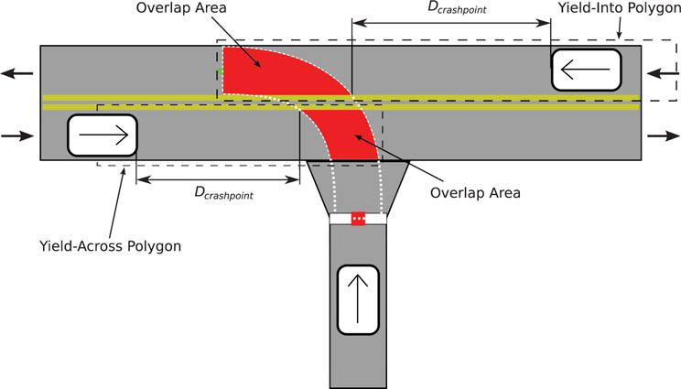

By broadcasting a sudden lane change event for the vehicles behind, they will be able to reduce their speed faster, before they can visually detect the car changing lanes, reducing the risk of an accident.

**Scenario 2: early obstacle avoidance**

Obstacles such as boulders, broken vehicles, or road work can cause massive trafﬁc as they usually involve obstructing an entire lane. On roads without closed lane signals, by broadcasting the detection of an obstacle on the lane, the vehicles behind would be able to change lanes before reaching the obstacle, reducing trafﬁc.

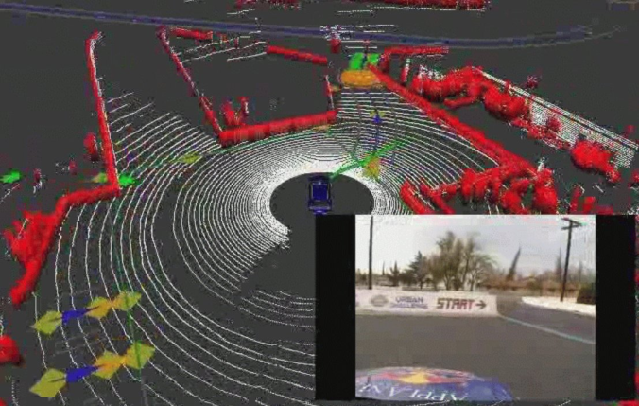

**Scenario 3: temporary stops**

Cars and buses can stop to pickup/drop passengers for short periods of time. As in the last example, this could also increase trafﬁc. These vehicles could send a notiﬁcation that they will stop for a short period of time, allowing vehicles that are approaching from behind to decide whether or not to change lanes based on their location and on how much time the vehicle is going to be stopped.

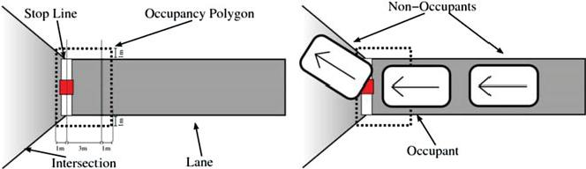

**Scenario 4: Sensoring**

The simulator provides other vehicle’s information, including their speed and relative position. Non-vehicle obstacles information on sensor fusion would need to be implemented. The project provides real sensor fusion data, but it requires previously collected sensor data to be used as a simulator.

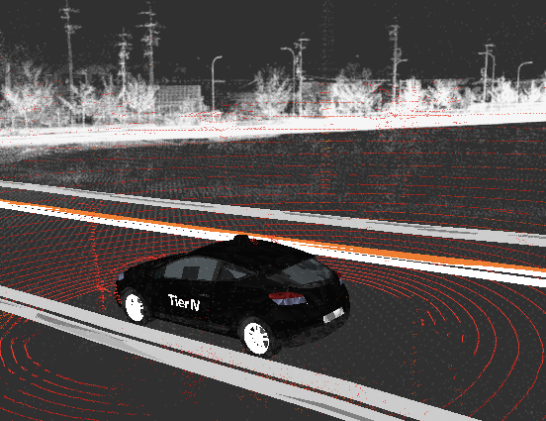

**Proposed system:**

Our proposed project puts forward an obstacle avoider robotic vehicle that uses ultrasonic sensors for this purpose. The system uses “AT mega 328 microcontroller” based prototyping board ie. ‘*Arduino’* to achieve this functionality. The robotic vehicle is designed to first track and avoid any kind of obstacles that comes it’s way. The vehicle achieves this smart functionality withthe help of sensors coupled with a microcontroller and motors. The entire system combined gives the vehicle an intelligent object detection and obstacle avoidance scheme. This system allows the vehicle to guide itself in case it encounters any obstacle. The obstacle detection is done using the different sensors. This is detected and a signal is passed on to the microcontroller. On receiving the signal it guides the vehicle in another direction by actuating the motors through the motor driver IC.

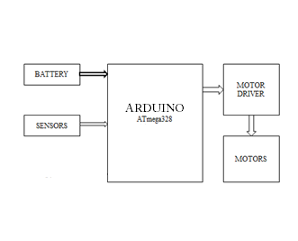

*#Fig : Block diagram*

**Introductions to the components**

**Arduino:**

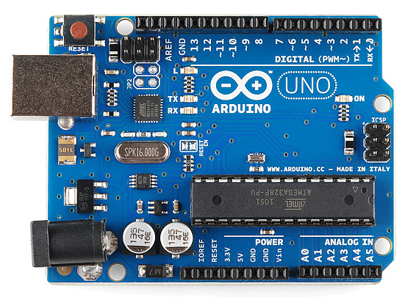

Arduino is a microcontroller based open-source platform used for building electronics projects. Arduino consists of both a physical programmable circuit board (often referred to as a microcontroller board) and a piece of software, or IDE (Integrated Development Environment) that runs on your computer, used to write and upload computer code to the physical board.

The recommended voltage for most Arduino models is between 6 and 12 Volts. Do NOT use a power supply greater than 20 Volts as you will overpower (and thereby destroy) your Arduino.

The Arduino has several different kinds of pins, each of which is labelled on the board and used for different functions.

**Sensors:**

The main goal of sensors is to perceive the environment, and thus they are a critical part of the system: we simply cannot avoid obstacles that we can’t sense. There is no sensor modality that is capable, by itself, to perceive all possible challenges in all environments, therefore a self driving car must combine sensors from multiple modalities. Lot of sensors are available for obstacle detection such as ultrasonic sensor, infrared sensor, PIR, camera and LIDAR (laser based sensor system), which has been considered as one of the most accurate schemes for generating spatial information about the shape and surface characteristics of any object.

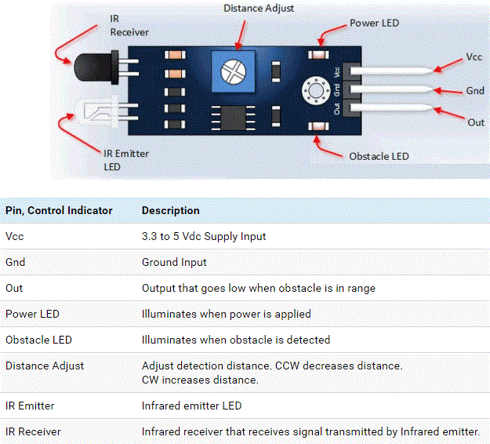

*Fig 4: IR sensor*

IR sensor is used to improve the overall vision system of mobile robot. IR sensors are widely used for measuring distances, so they can be used in robotics for obstacles avoidance. IR sensors are also faster in response time than ultrasonic sensors. In addition, the power consumption of IR sensor is lower than ultrasonic sensors. Active Infrared (IR) sensors can be an emitter and detector, which operate at the same wavelength. It is also known as photoelectric sensor working with reflective surfaces. IR sensor can be categorized as retro-reflective sensors and diffuse reflection sensors. Retro-reflective sensors are proper for harsh environment conditions and have much larger detection range than the diffuse reflective sensor.

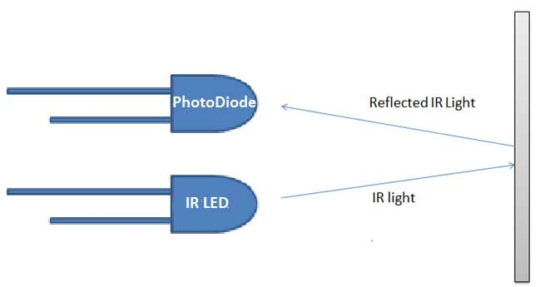

IR sensors use a specific light sensor that can detect a selective light wave length in the IR spectrum. When an object is close to the sensor, the light from the LED bounces off the object and into the light sensor as shown in above Figure.

**Motor driver:**

The L293D is quadruple high-current half-H drivers. It is designed to provide bidirectional drive currents of up to 600-mA at voltages from 4.5 V to 36V. Both devices are designed to drive inductive loads such as relays, solenoids, dc and bipolar stepping motors, as well as other high-current/high-voltage loads in positive-supply applications. All inputs are TTL compatible. Here Motor driver is used to control the motors and decides which motor will be moved or stopped in accordance to the incoming signal from the Arduino.

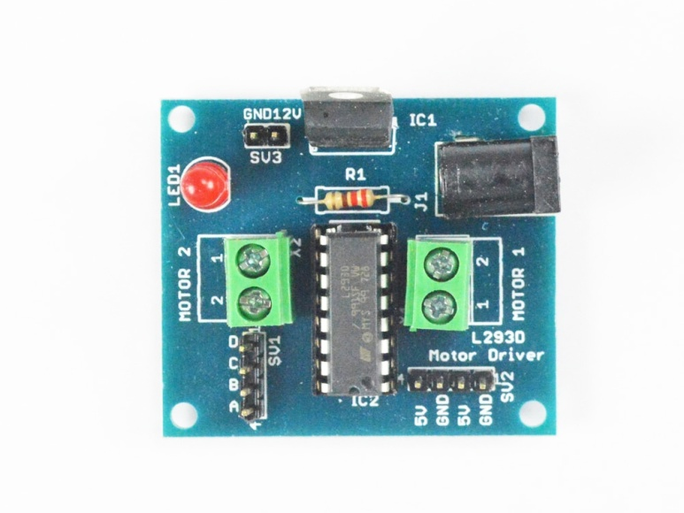

**DC Motor:-**

A DC motor is any of a class of rotary electrical machines that converts direct current electrical energy into mechanical energy. The most common types rely on the forces produced by magnetic fields. Nearly all types of DC motors have some internal mechanism, either electromechanical or electronic, to periodically change the direction of current flow in part of the motor.

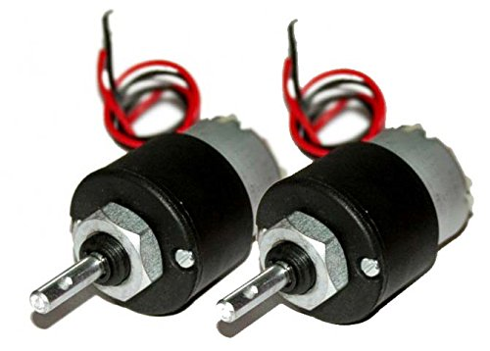

**Wheels:-**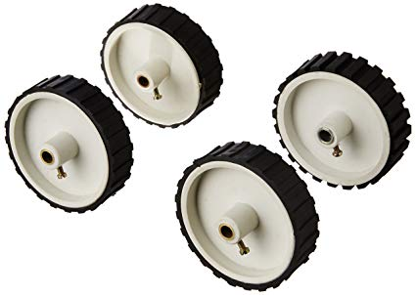

A circular object that revolves on an axle and is fixed below a vehicle or other object to enable it to move easily over the ground.

**Caster Wheels:-**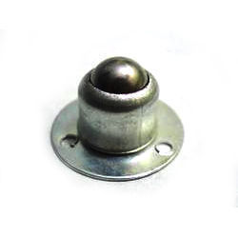

A caster (also known as castor according to some dictionaries) is a wheeled device typically mounted to a larger object that enables relatively easy rolling movement of the object. Casters are essentially housings, that include a wheel and a mounting to install the caster to objects (equipment, apparatus and more).

**Experiment Setup:**

Circuit diagram of the obstacle avoiding robot is given in Figure below. The hardware developed consists of Microcontroller Atmel ATMEGA 328 based Arduino Uno, IR sensors, DC geared motors (60 RPM) as differential driving system, and motor driver L293D. The Arduino is the central brain of the autonomous car. The IR detector (rear) is connected to the GPIO pin of Arduino. If any object is located at the rear part of the robot frame, the IR sensor output will alert the microcontroller that an obstacle is detected.

The IR sensor used as shown in Figure. The module has a in infra-red transmitter which lights up the surroundings and an infra red receiver which measures the amount of infra red that is reflected. If the reflected amount of light reaches above a certain threshold that means that light was reflected and so the signal pin is triggered. (goes from HIGH to LOW).

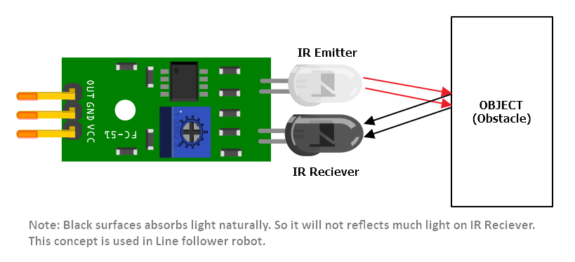

According to the detection the Arduino gives the command to motor driver for rotating the dc gear motor as following to the action plane. Here our action plane is basically based on, if the obstacle is detected on more than 3 sensor side the vehicle will stop else if it’s detects less than 3 sensor are actively detect the obstacle then its take a turn and make the parallel path with the obstacle. And it’s the case of no obstacle is detected its move in forward direction. Like this way this automatic driving vehicle is works

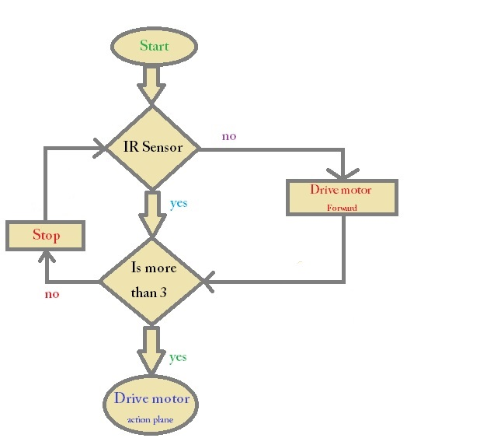

*# Flow chart of the obstacle avoidance autonomous car*

**Advantages & Disadvantages:**

***Table:* Autonomous Vehicle Operational Models Compared**

|  |  |  |  |
| --- | --- | --- | --- |
|  | **Advantages** | **Disadvantages** | **Appropriate Users** |
| **Personal autonomous**  **vehicles** - Motorists own  or lease their own self-  driving vehicles. | High convenience. Available without delay. Items, such as equipment, tools and snacks, can be left in vehicles. | High costs. Does not allow users to choose different vehicles for different trips, such as cars for commuting or trucks for errands. | People who travel a lot, reside in sprawled areas, want a particular vehicle, or leave items in their vehicles. |
| **Shared autonomous**  **vehicles** - Self-driving taxis  transport individuals and  groups to destinations. | Users can choose vehicles that best meet their needs. Door to door service. | Users must wait for vehicles. Limited service (no driver to help passengers carry luggage safely reach their door). Vehicles may be dirty. | Lower-annual-mileage  users. |
| **Shared autonomous rides** | Lowest costs. | Least convenience, comfort and speed, particularly in sprawled areas. | Lower-income urban  residents. |
| - Self-driving vans (*micro-* |
| *transit*) take passengers to |
| or near destinations. |

*# Autonomous vehicles can be personal or shared. Each model has advantages and disadvantages.*

**Reduced Stress, Improved Productivity and Mobility**

Autonomous vehicles can reduce driver stress and tedium. Self-driving cars can be mobile bedrooms, playrooms and offices, as illustrated below, allowing passengers to rest or be productive while travelling (WSJ 2017). This can reduce travel time unit costs.

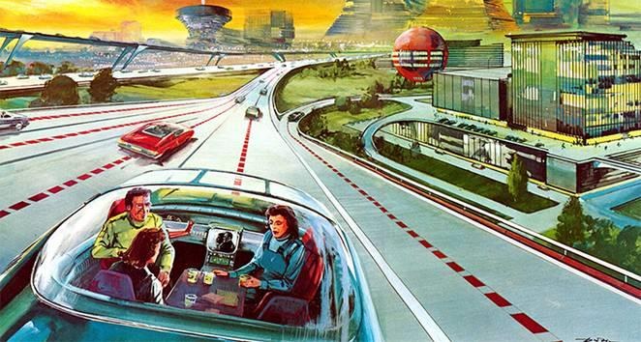 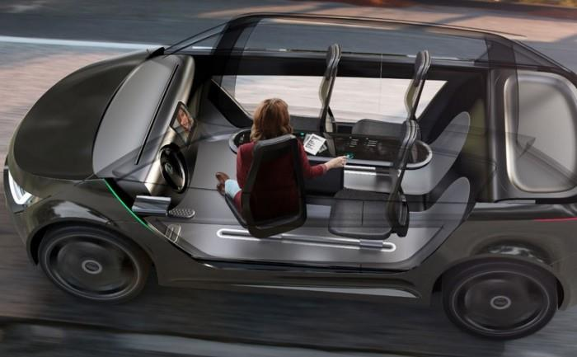

## Productivity and Relaxation While Travelling

**The Autonomous Vehicle Travel Experience**

Autonomous vehicles are often illustrated (see below) with happy, well-dressed passengers lounging or working in tidy self-driving cars that look like science fiction spaceships. However, the actual experience will probably be less idyllic.

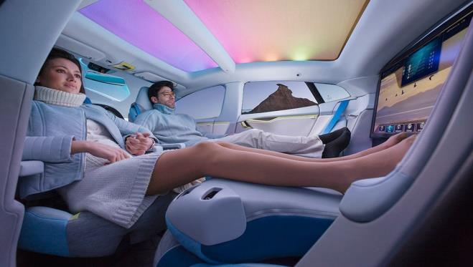

Self-driving vehicles will allow all vehicle occupants to rest, read, work and watch television (rather than only listen to audio), but for safety sake they should wear seatbelts, and like any confined space, vehicle interiors can become cluttered and dirty. Manufactures will probably produce vehicles with seats that turn into beds and mobile offices.

**Conclusion:**

In this project we propose the autonomous cars into assistive technology for blind and visually impaired people. Vehicle can move in different directions like Forward, Backward, Left, and Right. Based on the object present in front of the vehicle .if it is living object then it waits for the obstacle status and if non-living objects are present in its path then it changes the direction of vehicle direction. Vehicle tracking system is also used to detect the location of the vehicle and also for accident detection.

**References:**

* N. Alsharif, S.Cespedes, and X. S.Shen. “iCAR: Intersection-based connectivity aware routing in vehicular ad hoc networks”. In: 2013 IEEE International Conference on Communications (ICC). June 2013, pp. 1736–1741. DOI: 10.1109/ICC.2013.6654769.
* [www.vtpi.org](http://www.vtpi.org)
* 4 Mark Campbell et al. “Team Cornell: Technical Review of the DARPA Urban Challenge Vehicle”
* www.darpa.mil/grandchallenge/TechPapers“Smartphone-based Obstacle Detection for Visually Impaired People”, 2017 International Conference on Innovations in Information, Embedded and Communication Systems (ICIIECS).
* “Enabling Independent Navigation for Visually Impaired People through a wearable Vision-Based Feedback System”, 2017 IEEE International Conference on Robotics and Automation (ICRA) Singapore, May 29 - June 3, 2017.
* “Obstacle Avoidance Robot”, International Journal of Science, Engineering and Technology Research (IJSETR), Volume 5, Issue 2, February2016.
* “Road Terrain Detection: Avoiding Common Obstacle Detection Assumptions Using Sensor Fusion”, In 2014